% cd /usr/local  
% wget [https://archive.apache.org/dist/maven/maven-3/3.5.3/binaries/apache-maven-3.5.3-bin.tar.gz](https://www.google.com/url?q=https%3A%2F%2Farchive.apache.org%2Fdist%2Fmaven%2Fmaven-3%2F3.5.3%2Fbinaries%2Fapache-maven-3.5.3-bin.tar.gz&sa=D&sntz=1&usg=AFQjCNEpSPPixUr2m4EPG9QNUoBTR3tedw) % tar xzf apache-maven-3.5.3-bin.tar.gz  
% ln -s apache-maven-3.5.3  maven  
export M2_HOME=/usr/local/maven  
export PATH=${M2_HOME}/bin:${PATH}

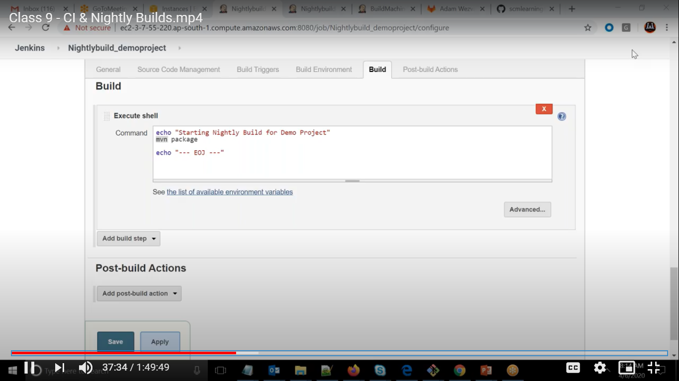

Adding maven in globally

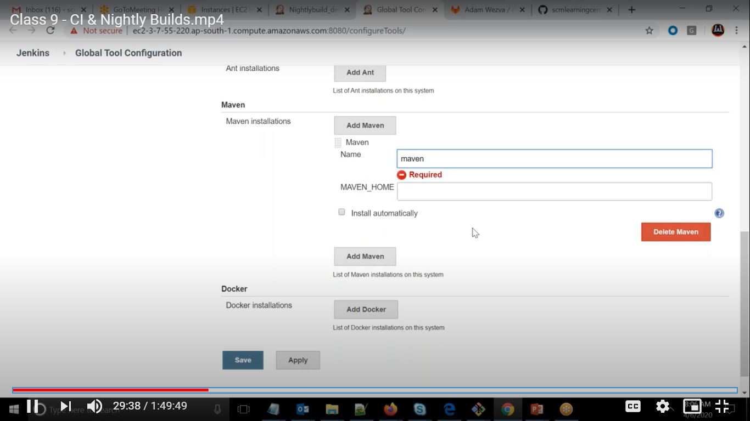  
First time it got failed

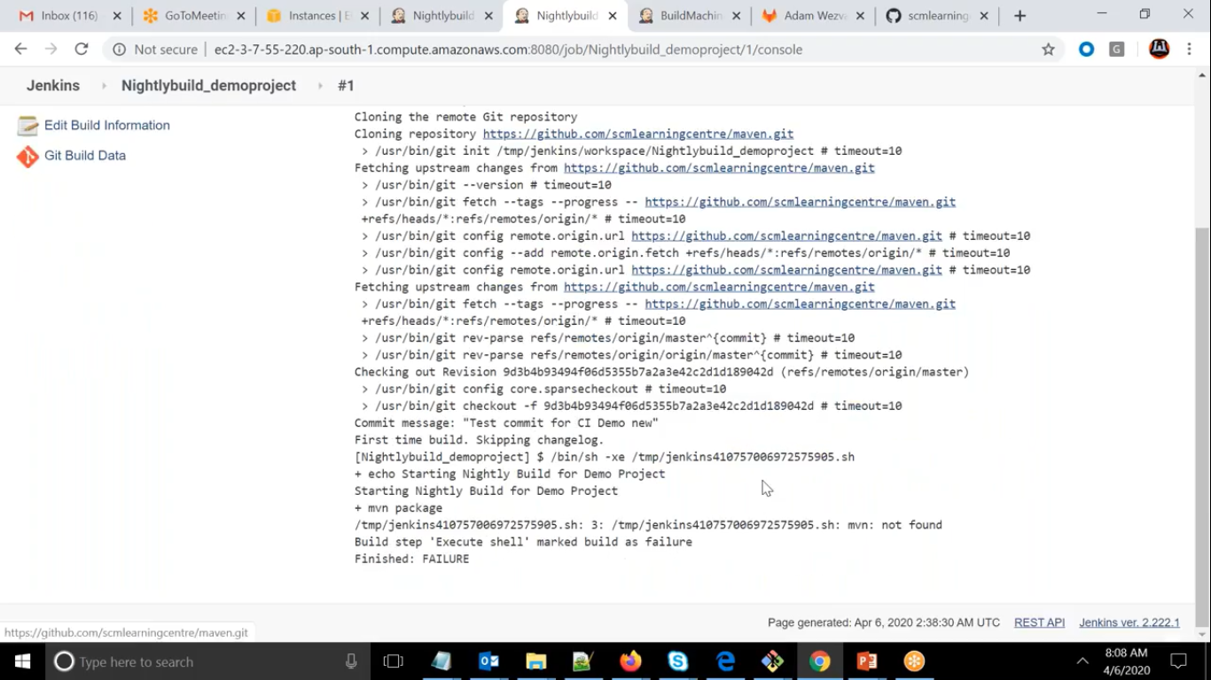

Jenkins is not able to pick path variable

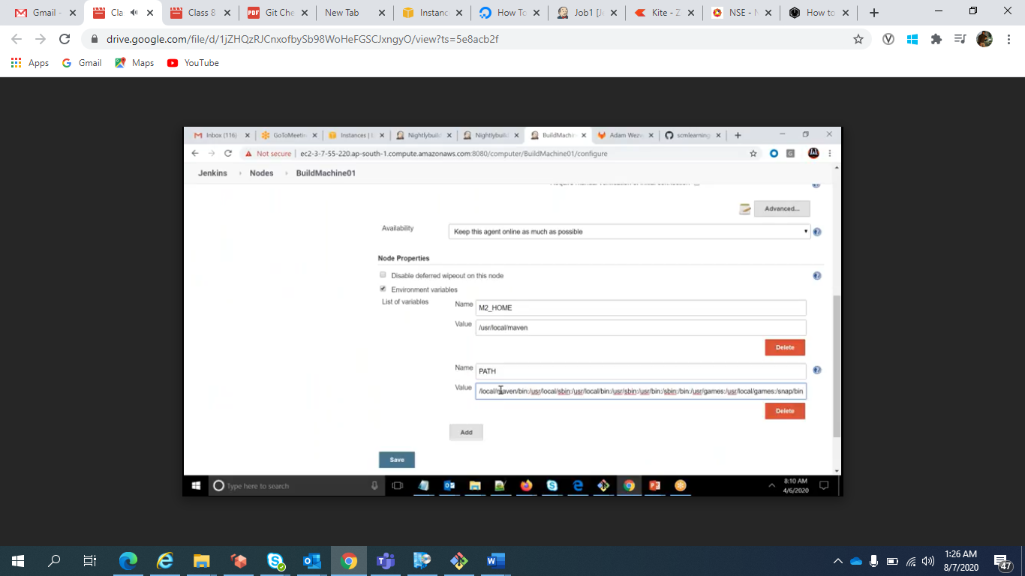

Setting the Path Variable

Now its failed due to JAVA_HOME

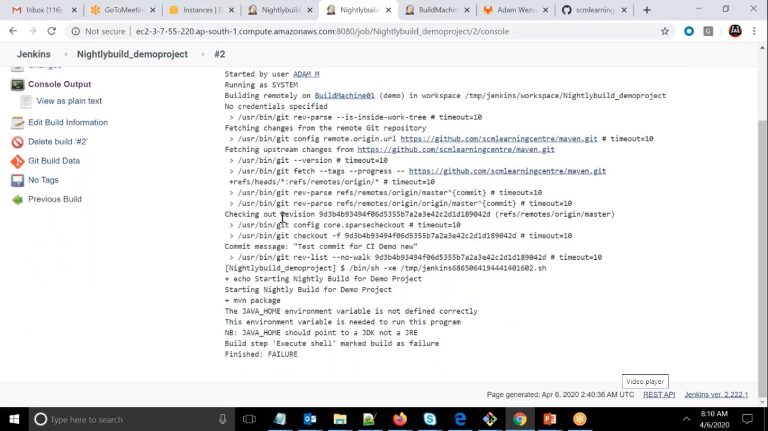  
Taking Java Home

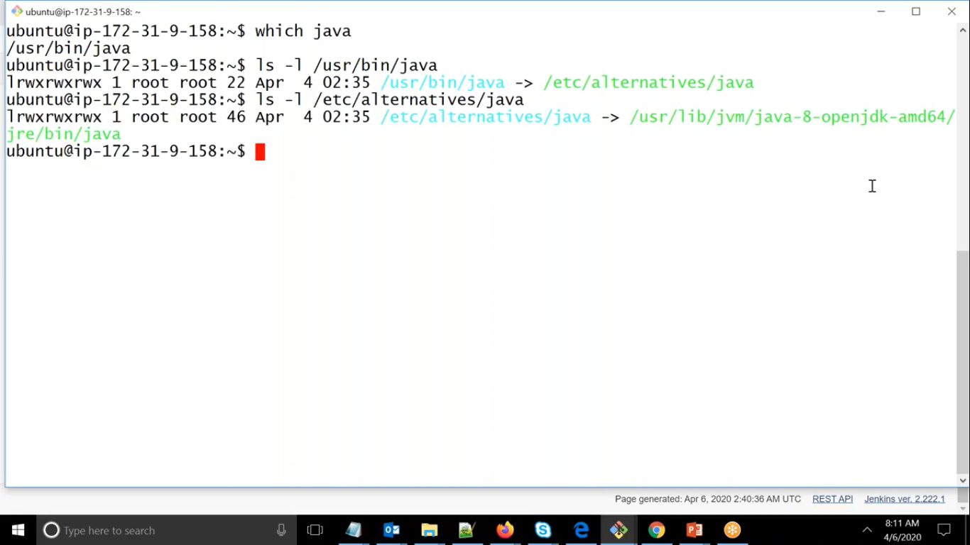

Adding it in machine

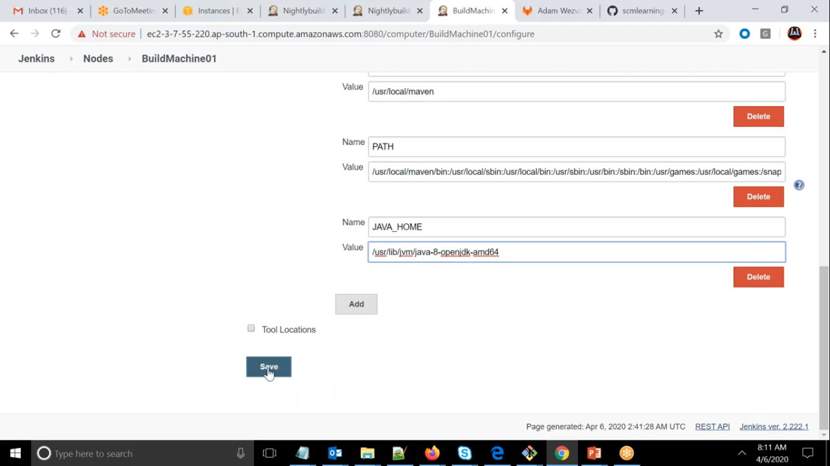

Now it is successfully executed

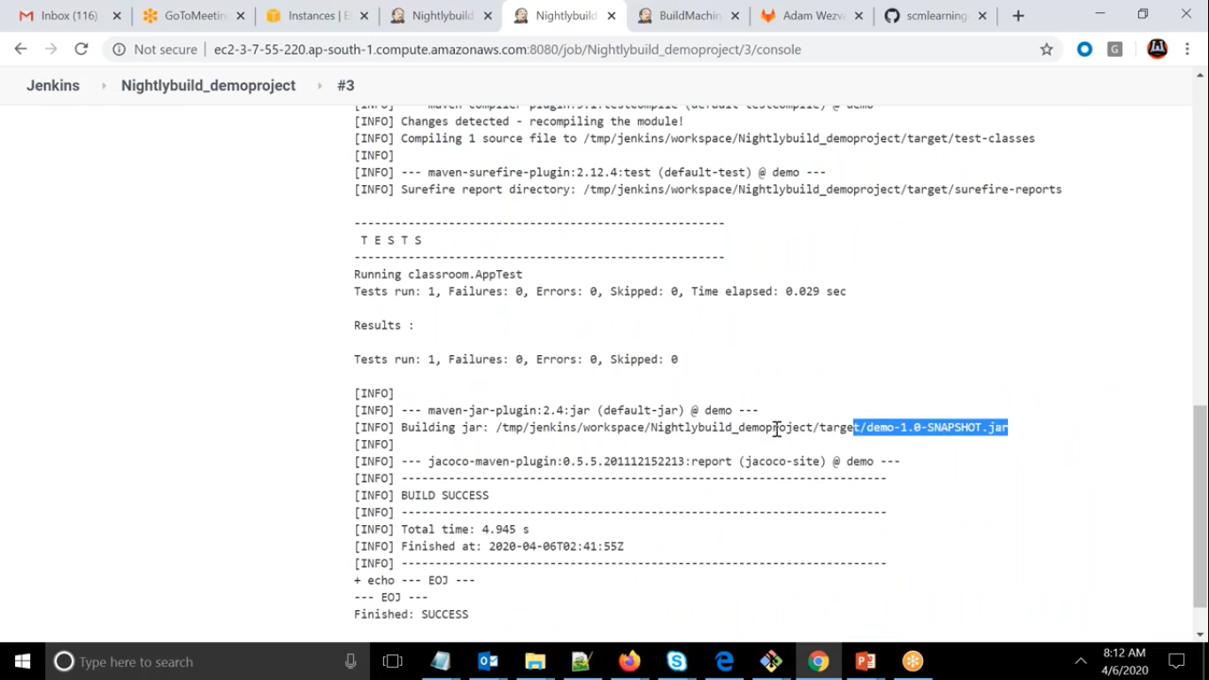

So what we followed in this task.

1. Which machine
2. Which repo, any credentials
3. When it has to triggered
4. What exactly it has to do

1.

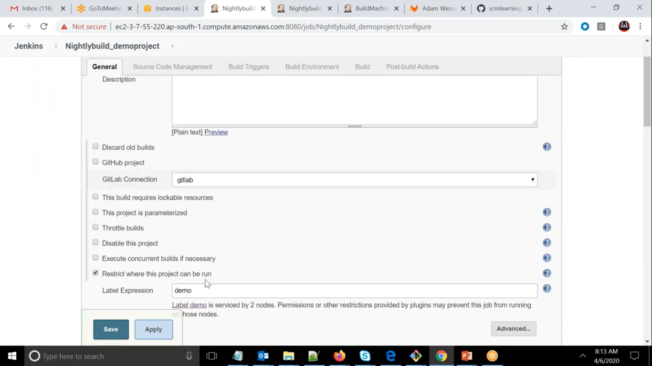

2.

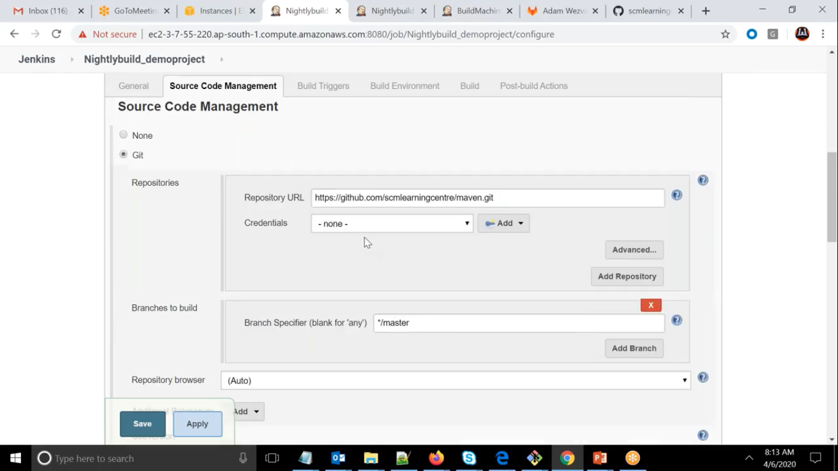

3.

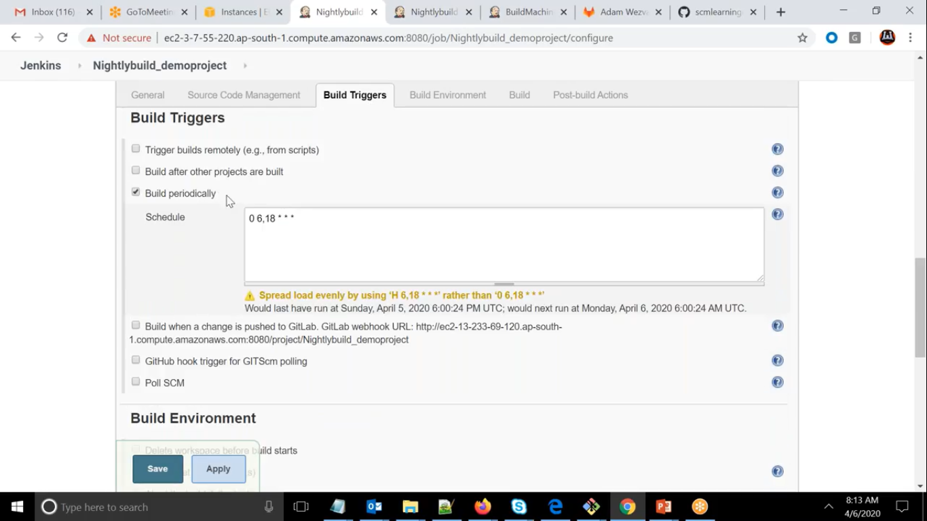

4.

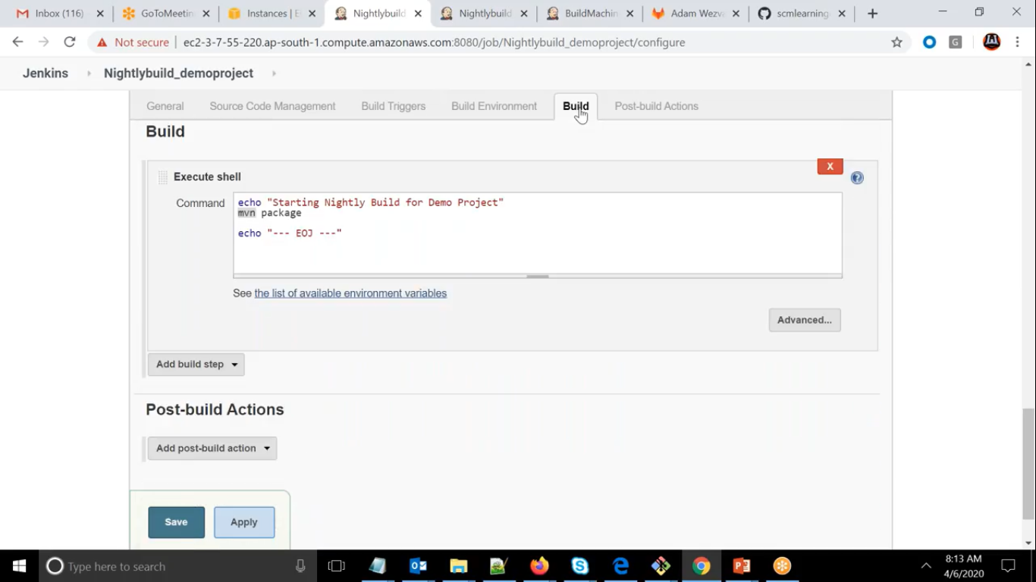

Difference between nightlybuild and CI

NightlyBuild happens at particular time daily whereas CI happens whenever new checkin is done

CI process

CI Job:  
 * Poll SCM  
    - Central Repo  
    - How frequently  
 * Integrate (git pull)  
 * Build (mvn package

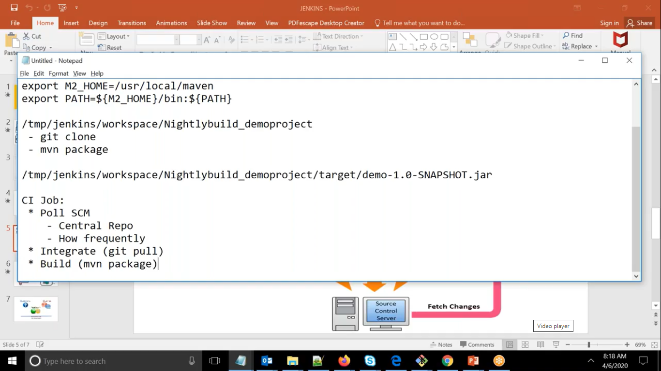

Where it should run

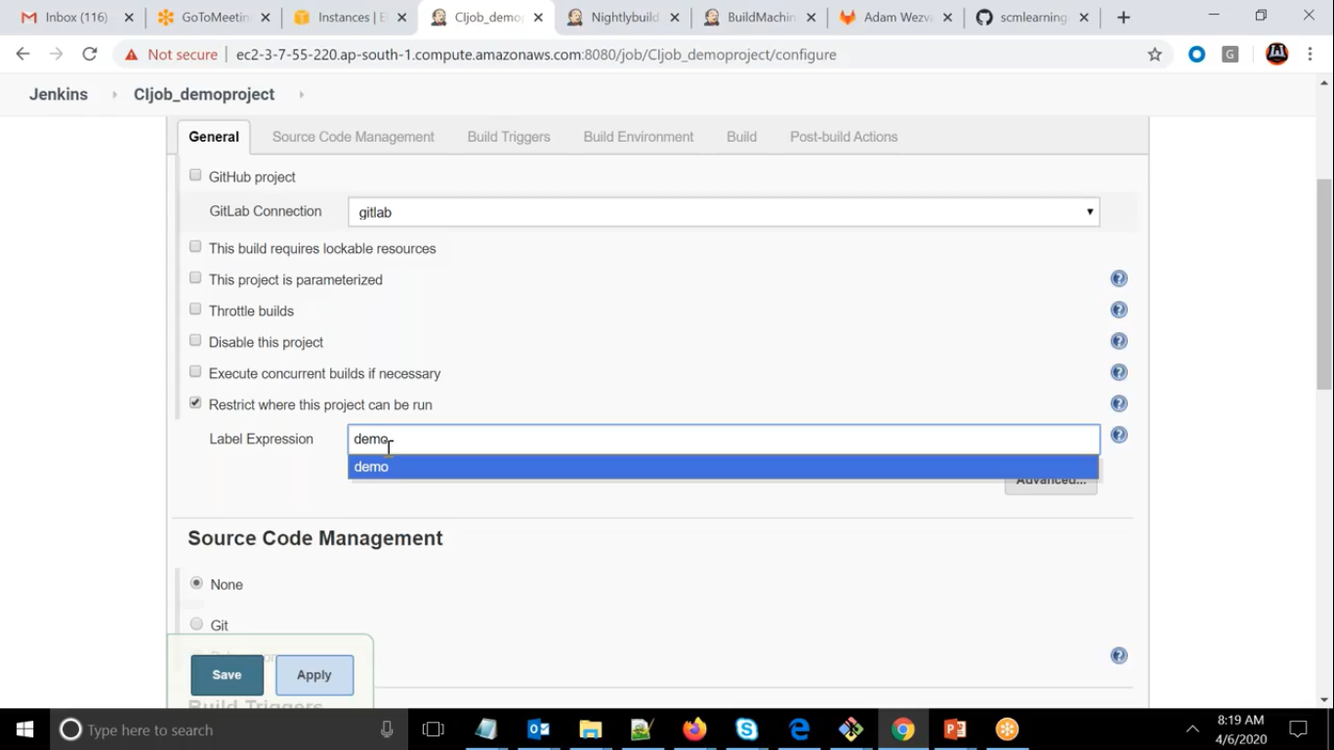

Which Repo

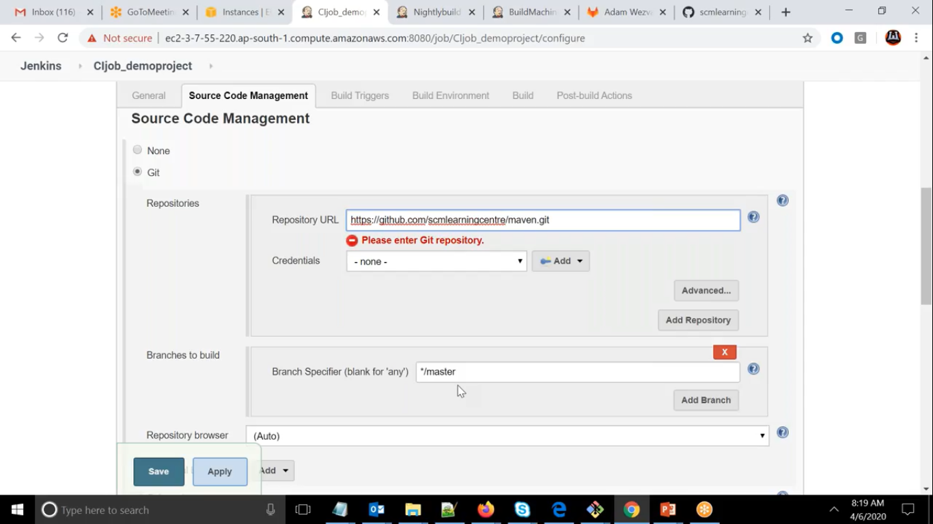

How Frequently

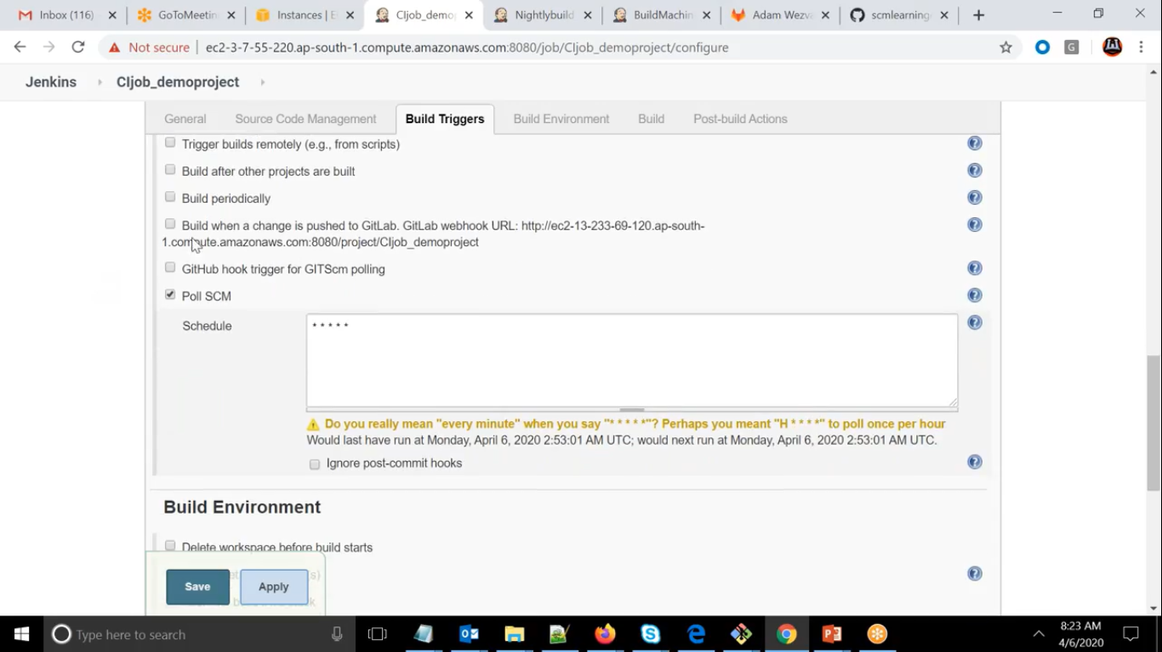

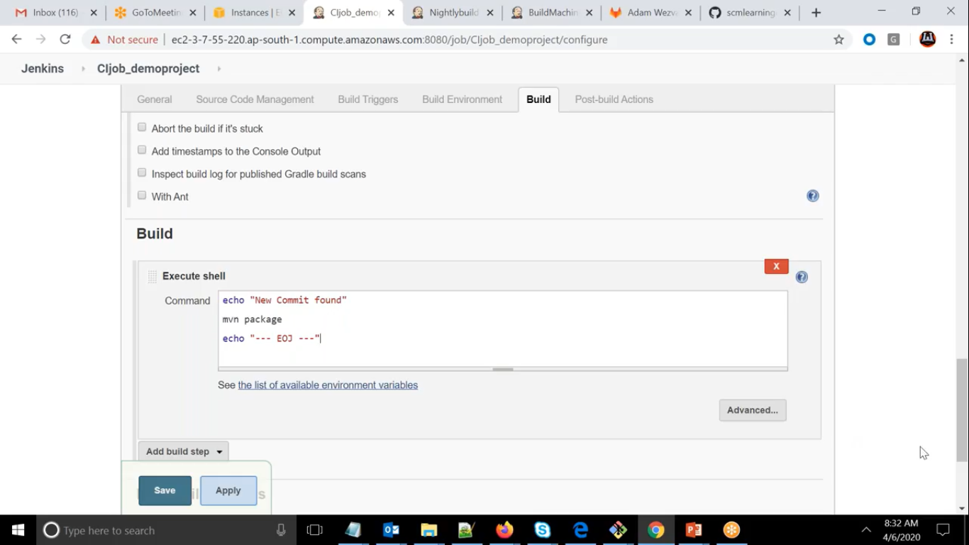

Checking for Polling

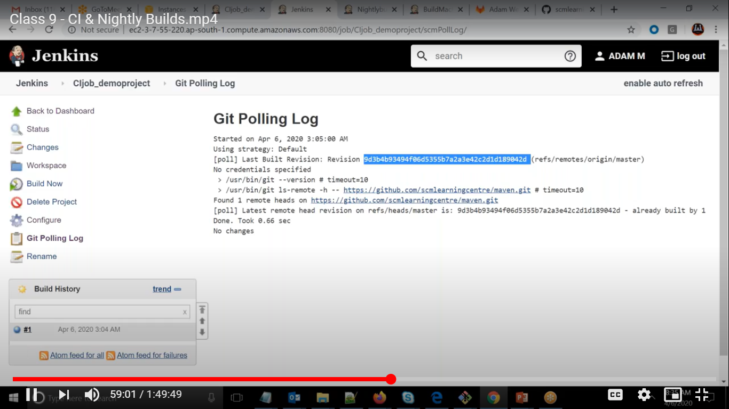

No Changes so nothing it is doing.

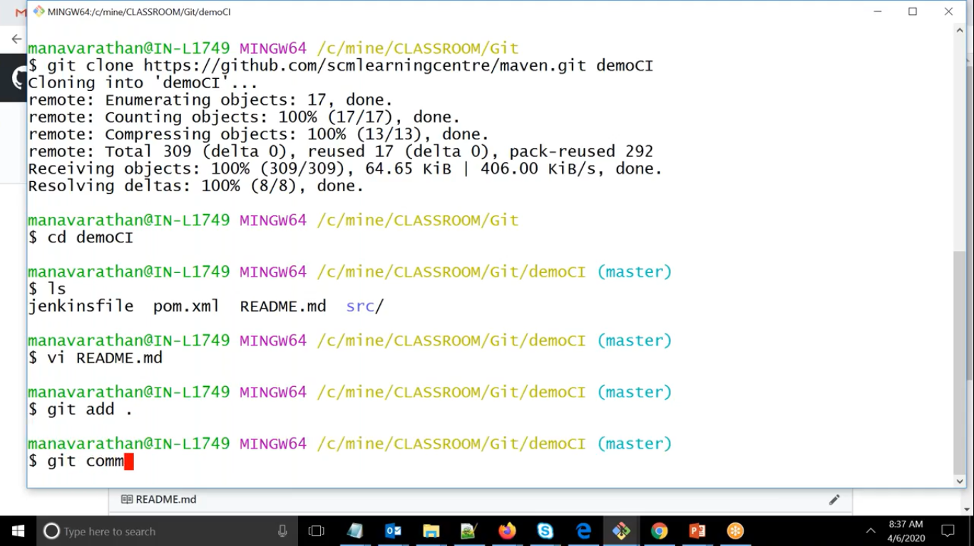

Now doing changes

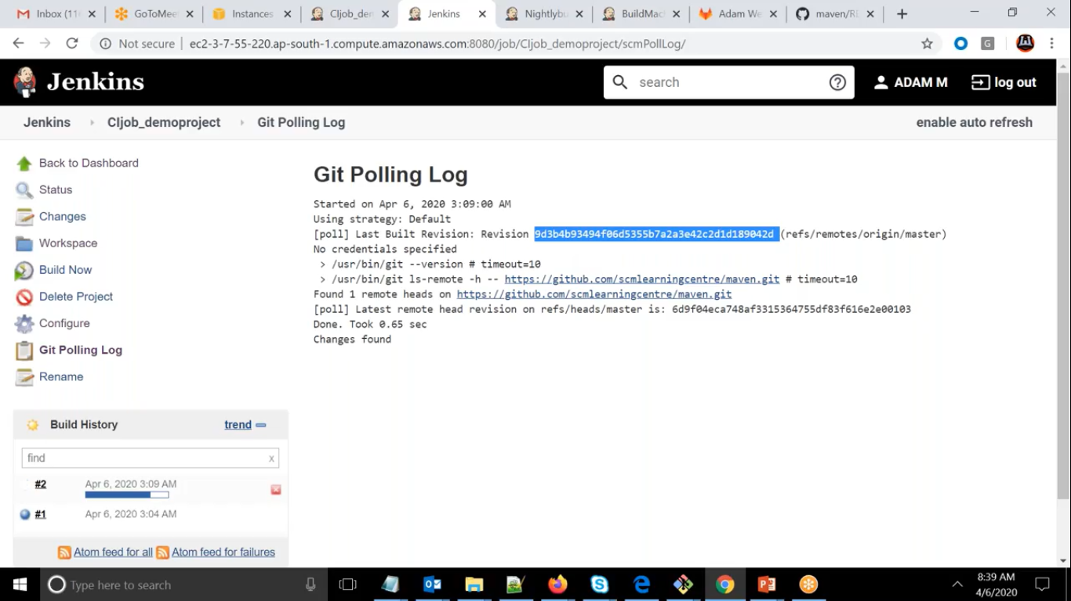

Its Found the changes and triggered

Web Hooks

It is the process in that whenever changes happens in central repository in gitlab it will triggered job in the Jenkins

========WebHooks=======  
* Install "Gitlab Plugin" on Jenkins & restart Jenkins  
 [https://plugins.jenkins.io/gitlab-plugin/](https://www.google.com/url?q=https%3A%2F%2Fplugins.jenkins.io%2Fgitlab-plugin%2F&sa=D&sntz=1&usg=AFQjCNHrtGrvsXfeUW1SFY2puip2Fv3LOg)  
  
* Generate Personal Access Token in Gitlab i.e  
  User settings -> Access tokens   
  
* In Jenkins add credentials for Gitlab API token with the above value  
  
* Once the API Access has been setup, we can configure the connection between Jenkins and GitLab.  
  - This happens in the Mange Jenkins -> Configure System -> Gitlab  
  - Uncheck the box "Enable authentication for '/project' end-point"  
  
* Create Webhook: Go to the Gitlab project -> Settings  
  - Add URL "http:<JenkinsURL>:8080/project/<JobName>"  
  - Enable "Push Events" under Trigger  
  - Uncheck "Enable SSL verification"

1. Install gitlab plugin and restart

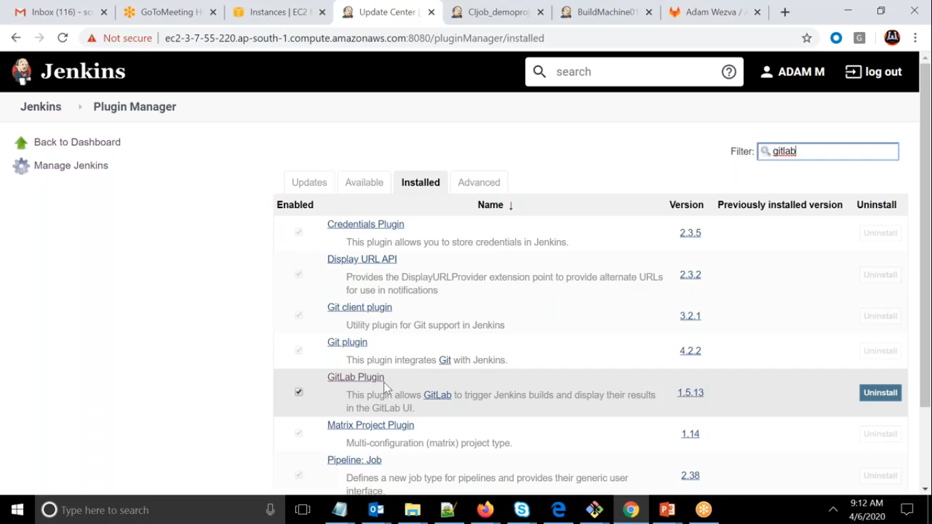

Generate Access Token

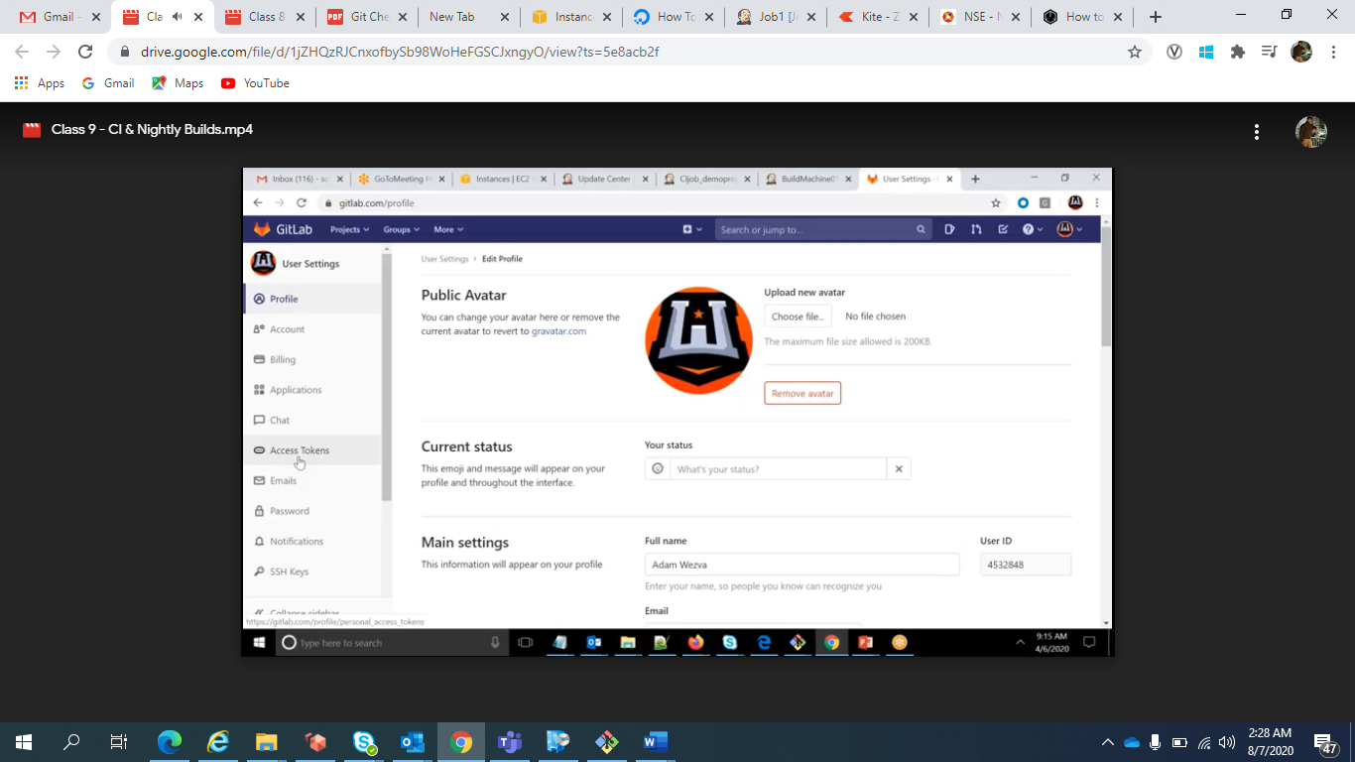

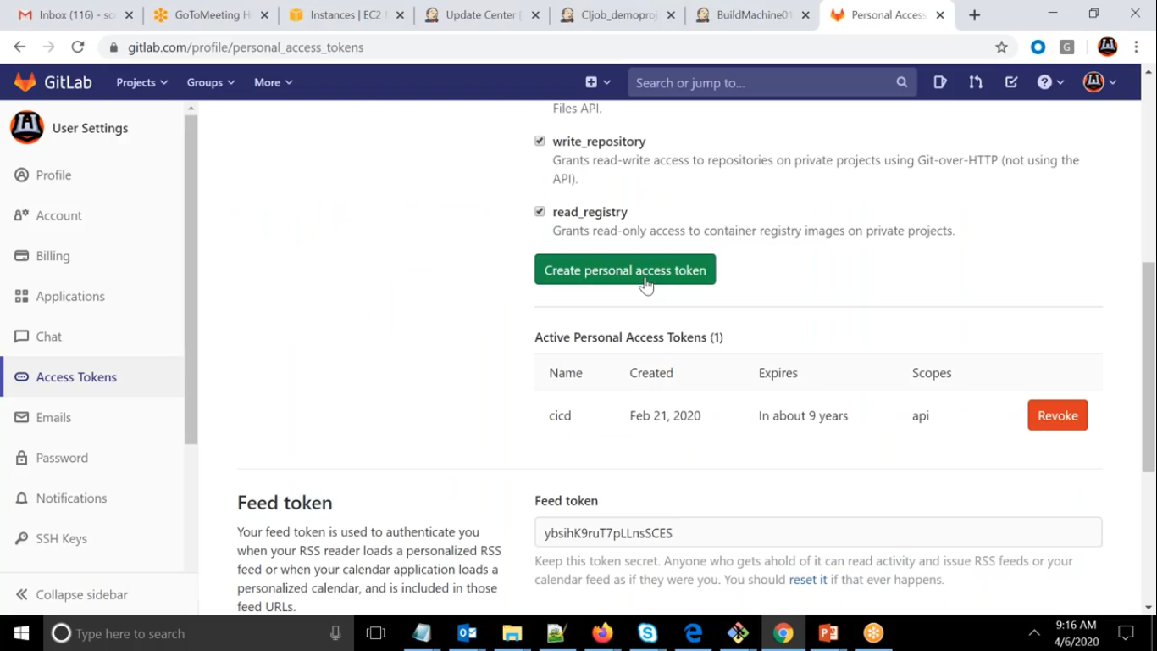

Once generated make note of token.

Add in Jenkins this token

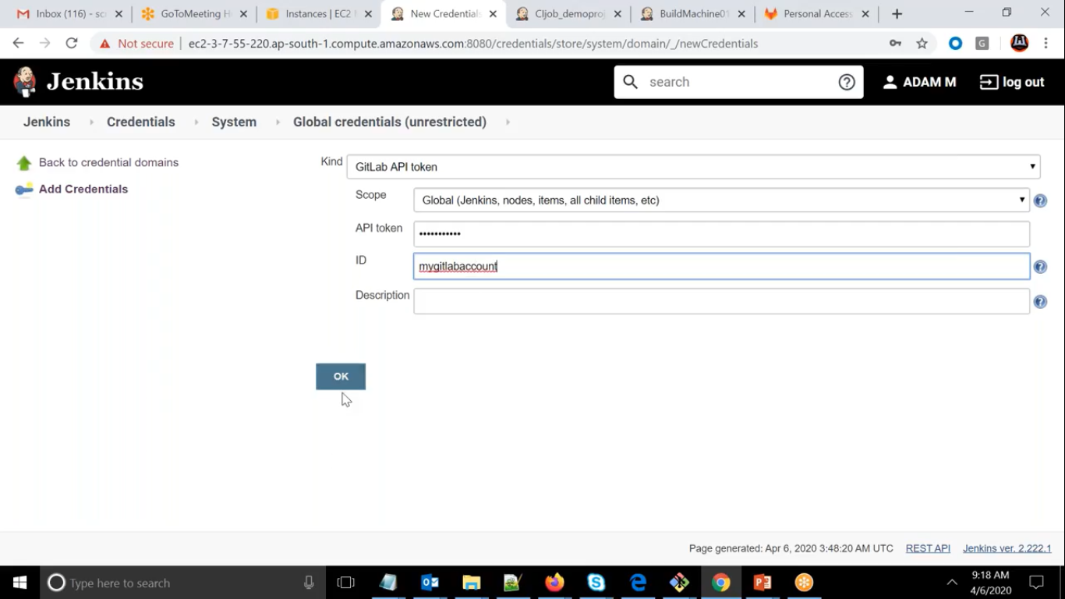

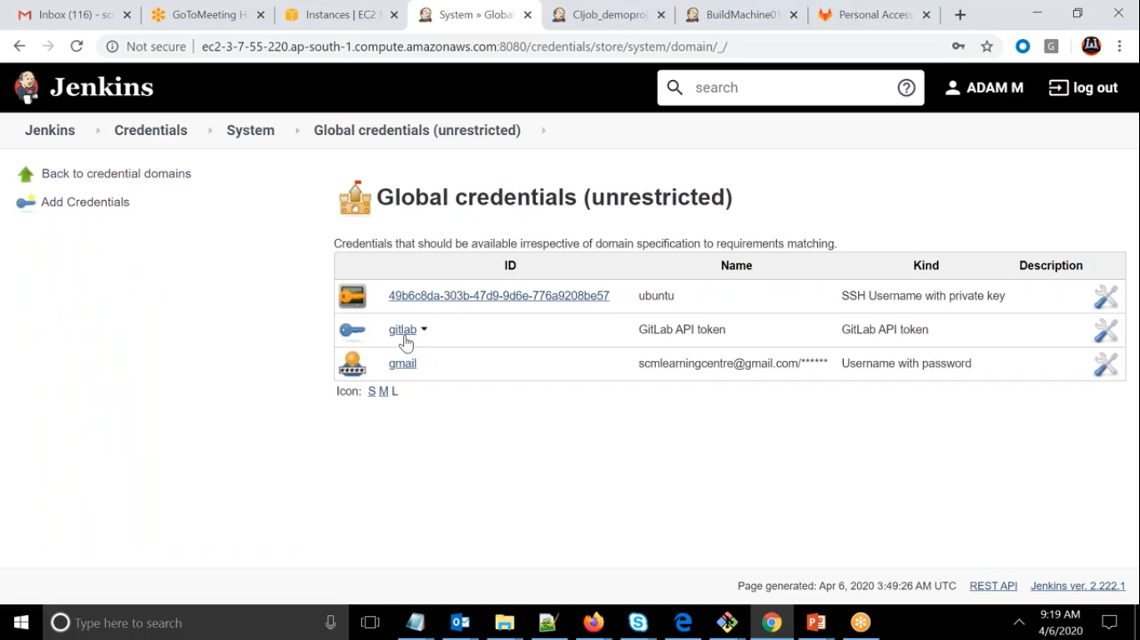

Add in configure system

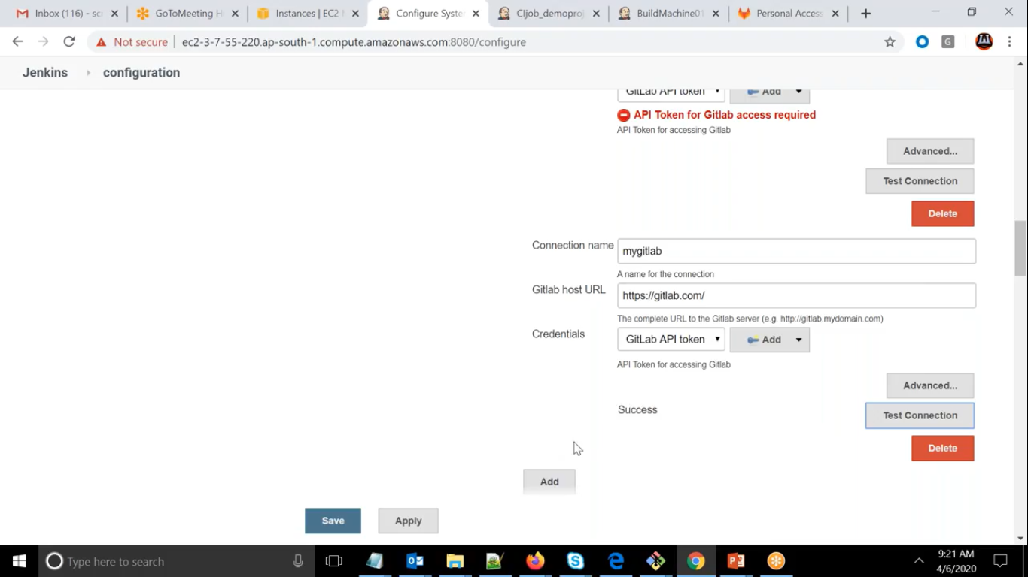

Go to specific projects

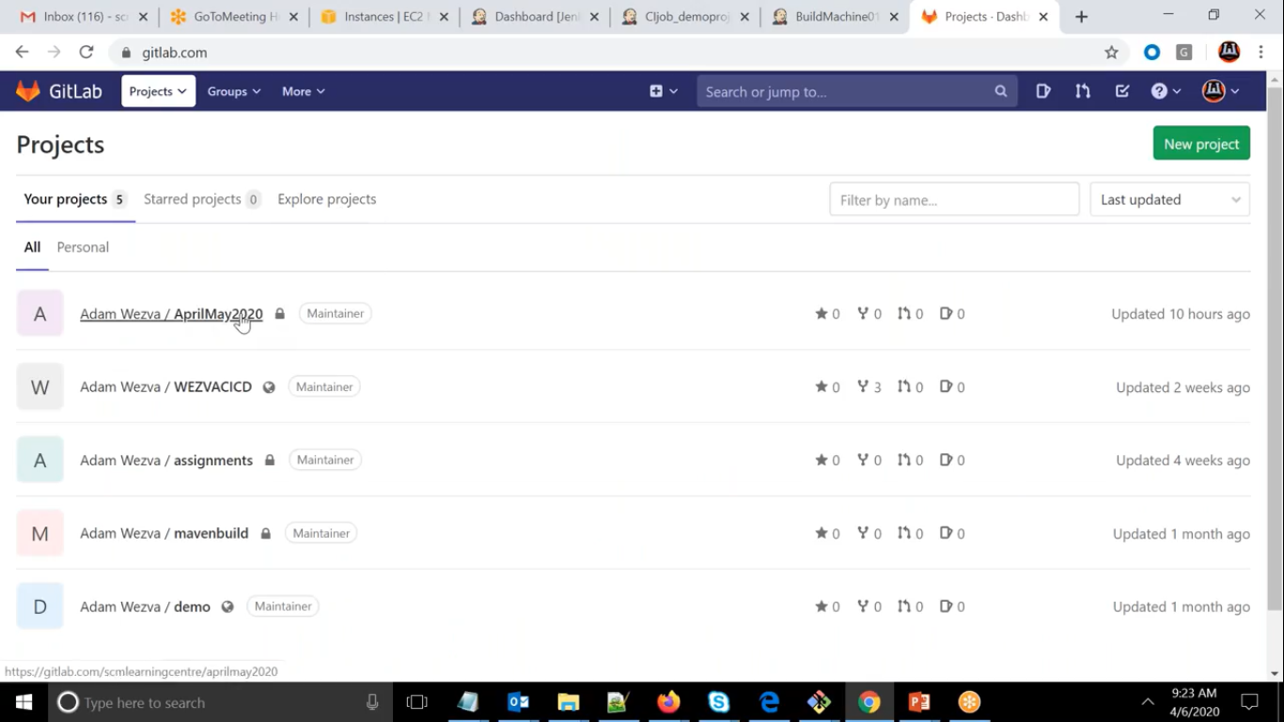

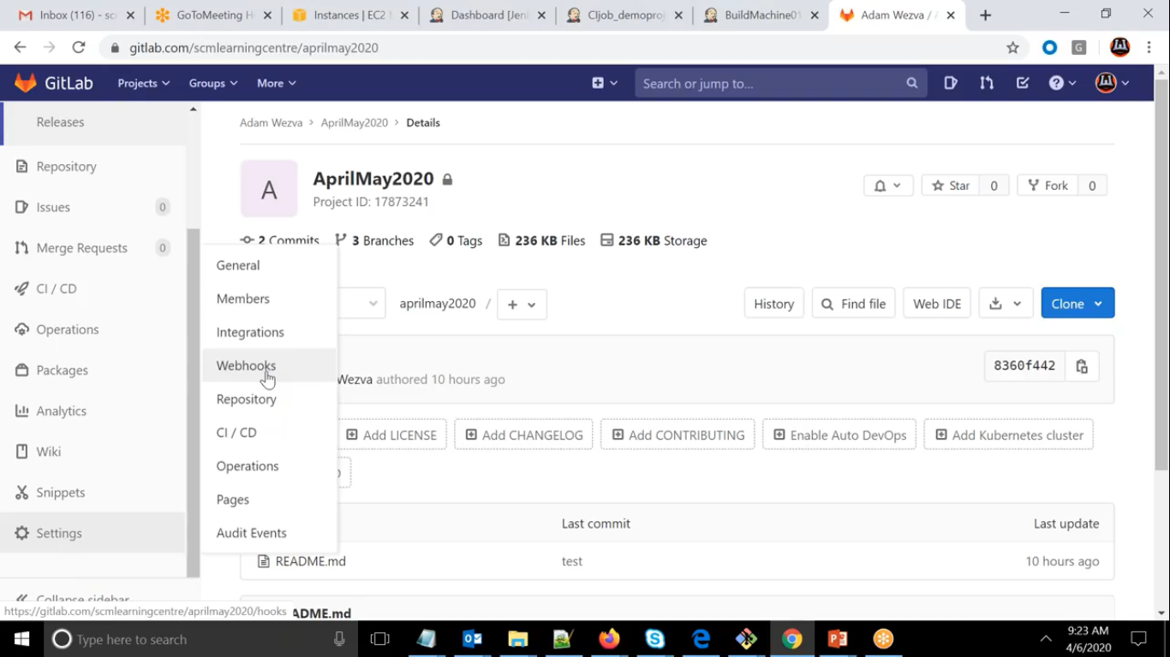

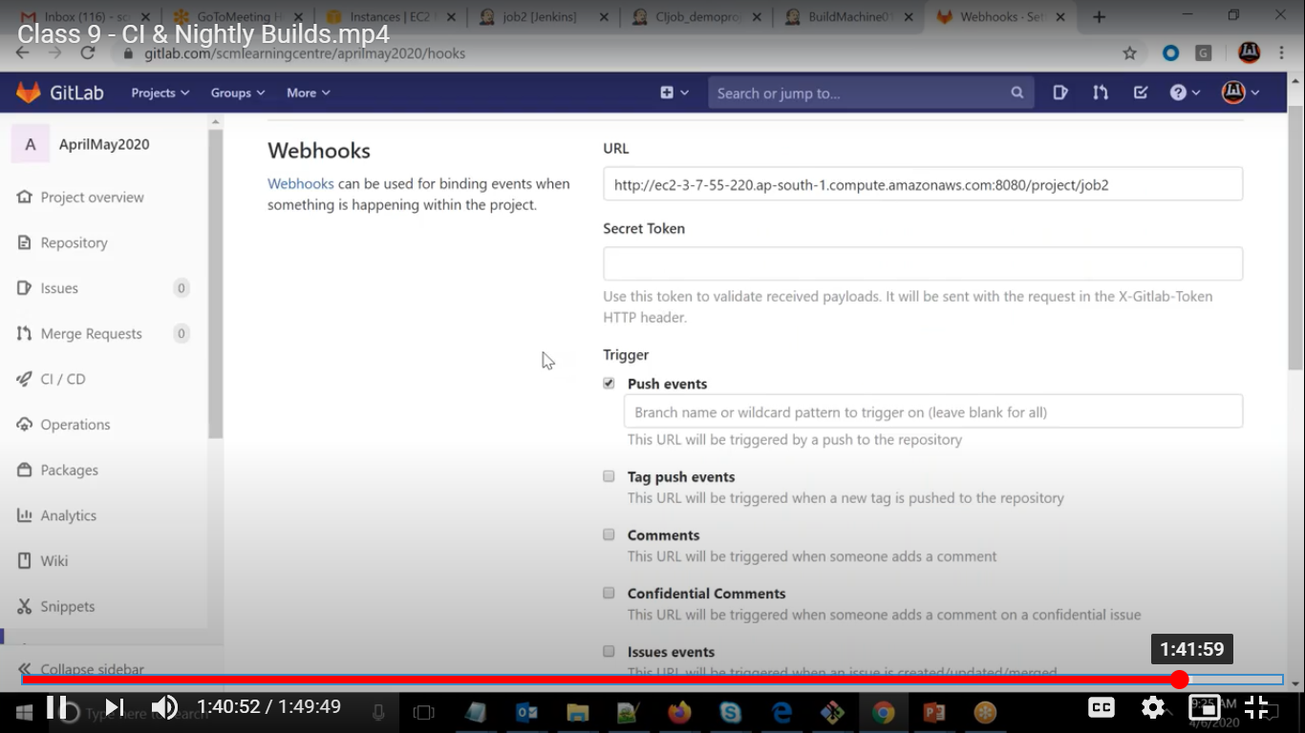

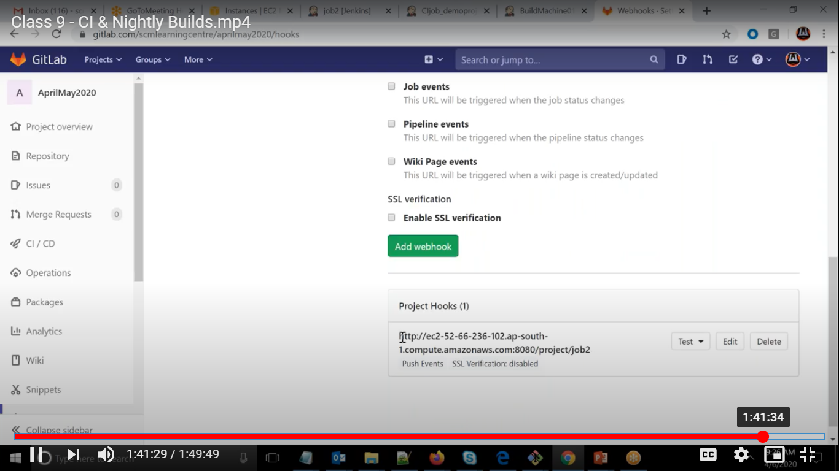

Now come to Jenkins job02

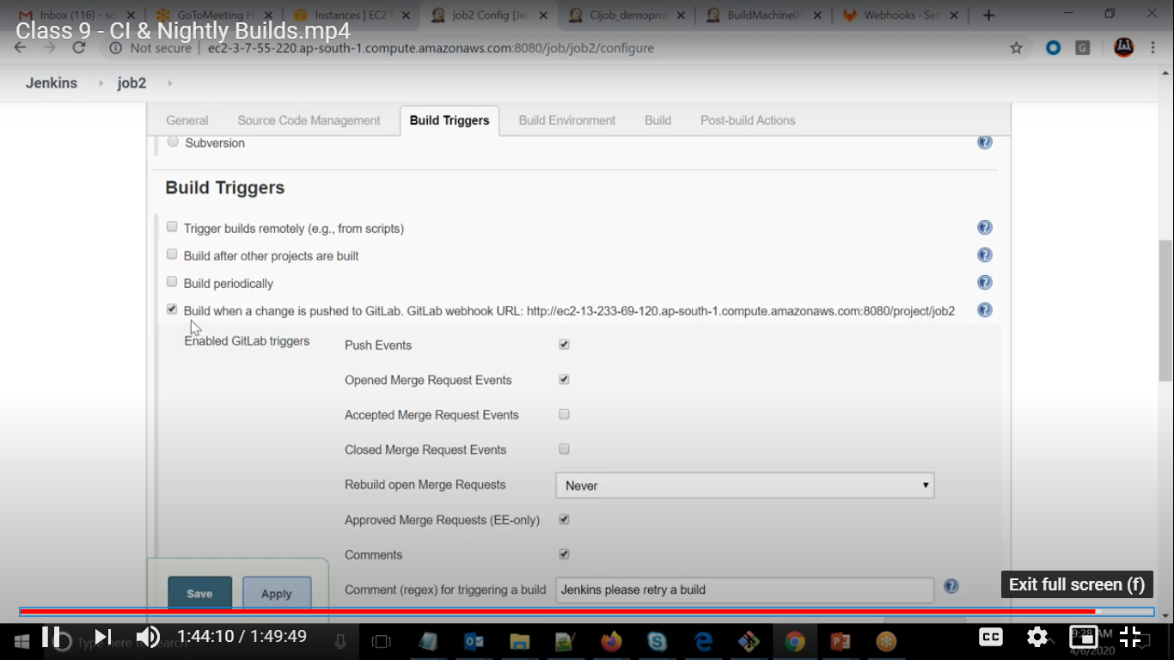

Test based on push

